# Ley Line Network Generator

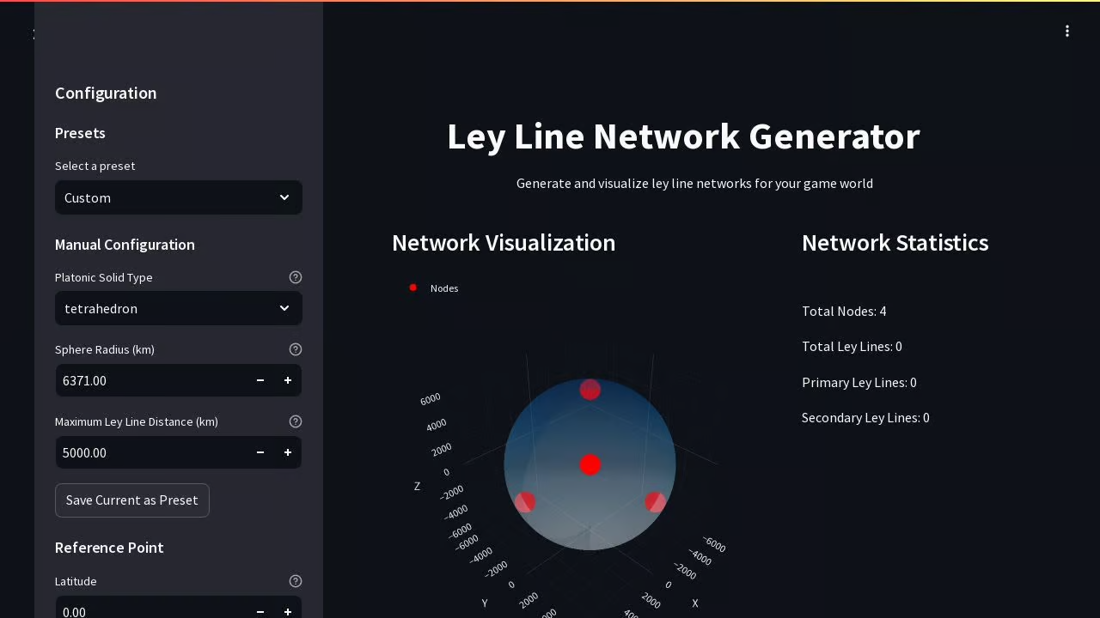

## Importance and Game Integration

### Introduction

The Ley Line Network Generator is a powerful development tool designed to accurately simulate and visualize ley line networks over real-world geographic terrain. This tool forms the backbone of the *FusionGirl* game world, ensuring an immersive and realistic environment that aligns with the game’s thematic emphasis on psionic energy, Universal Language, and interdimensional travel.

## <https://github.com/Jthora/leyLineNetworkGenerator>

# Why This Is Important

1. **Realism and Immersion**
   * **Accurate Geographic Terrain:**
     + The generator uses geographic height map data to create terrain maps that mirror real-world topography. This ensures that the game world feels authentic, allowing players to interact with familiar and believable environments.
   * **Scientific and Mythological Convergence:**
     + Ley lines are a fascinating concept that bridges science, mythology, and spirituality. By generating these networks based on real-world geographic coordinates, *FusionGirl* grounds its psionic and interdimensional mechanics in a framework that resonates with both mystics and scientifically inclined players.
2. **Procedural Game World Design**
   * **Dynamic World Building:**
     + The tool enables the creation of procedurally generated ley line networks that can change between realities and timelines. This adds variety and replayability, as no two game sessions are the same.
   * **Integration with Game Mechanics:**
     + Ley line nodes generated by the tool act as hubs for missions, crafting resources, base-building locations, and psionic focal points. This ensures a seamless blend of gameplay and narrative elements.
3. **Enhancing Exploration Mechanics**
   * **Discovery and Navigation:**
     + Players navigate the world using the Magneto Speeder, and ley lines act as natural highways for exploration. A scientifically accurate and visually compelling ley line network encourages players to delve deeper into the game world, uncovering secrets and strategic opportunities.
   * **Rift Stabilization Points:**
     + Key gameplay mechanics, such as stabilizing interdimensional rifts, are tied to ley line nodes. Accurate ley line placement enhances these mechanics, tying player actions to meaningful locations within the game.

###### The Ley Line Network Generator is more than a development tool; it is the foundational system for creating a game world that is scientifically plausible, thematically rich, and endlessly engaging. By incorporating real-world geography, advanced visualization, and modular customization, it ensures that FusionGirl delivers an unparalleled experience of exploration, strategy, and storytelling. This tool is a testament to the game’s commitment to innovation, realism, and player immersion.

# Features and Their Utility in the Game

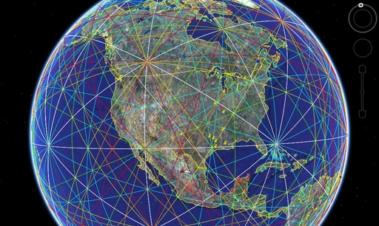

## Interactive 3D Visualization

* **Use in Development:**
  + Developers can visually assess the generated ley line network in a 3D space, ensuring optimal placement of nodes and connections relative to geographic features.
* **Use in Gameplay:**
  + Interactive visualization translates to in-game mechanics, allowing players to map their journey along ley lines with precision.

### Support for Platonic Solid Base Structures

* **Utility in Ley Line Design:**
  + Platonic solids, revered for their geometric and metaphysical significance, are used as base structures for ley line generation. This feature ensures that the network aligns with universal principles of symmetry and harmony, mirroring themes of Universal Language and psionics in the game.

##### Parameter Controls for Network Generation

* **Customization:** 
  + Developers can adjust parameters like sphere radius and maximum connection distance to generate networks that suit specific narrative or gameplay needs.
* **Dynamic Scaling:**
  + Networks can scale across local, planetary, or cosmic levels, aligning with *FusionGirl’s* multiverse mechanics.

##### Preset Management

* **Efficiency in Development:**
  + Saved configurations allow developers to quickly iterate and test various ley line setups without recreating networks from scratch.
* **Player Integration:**
  + Custom presets could be offered to players as DLC content, allowing them to explore alternative ley line configurations tied to unique missions or realities.

##### Batch Generation Capabilities

* **World Building:**
  + Multiple ley line networks can be generated simultaneously for different realities or multiverse phases, streamlining the development of procedurally generated worlds.
* **Statistical Comparisons:**
  + Developers can analyze network statistics to ensure balance and coherence across various configurations.

##### Network Statistics and Analysis

* **Strategic Placement:**
  + Metrics like node counts and connection success rates guide developers in placing key in-game elements, ensuring a balanced experience.
* **Optimized Gameplay:**
  + High-density areas can house critical missions or faction bases, while sparse areas encourage resource gathering and exploration.

##### Reference Point Visualization

* **Narrative Alignment:**
  + Custom latitude and longitude inputs ensure that key locations in the game world align with real-world sites of historical or mythological significance.
* **Player Engagement:**
  + Visuals and grids guide players, tying gameplay objectives to ley line nodes.

## Benefits for FusionGirl

### 1. Seamless Narrative Integration

The ley line networks generated by this tool provide a tangible framework for *FusionGirl’s* core themes:

* Nodes represent psionic focal points where players engage in high-stakes missions.
* The interconnected network mirrors the multiverse mechanics, emphasizing interdimensional travel and collaboration.

### 2. Expanding Gameplay Possibilities

The tool creates a dynamic world-building system where:

* Players unlock ley line nodes to gain access to new regions, missions, and resources.
* Rift stabilization mechanics tie directly to ley line intersections, creating strategic gameplay challenges.

### 3. Sustainability for Long-Term Development

* The generator’s modular design allows developers to iterate and expand the ley line system as new content is introduced, ensuring scalability for future updates and sequels.
* Batch generation capabilities reduce development time and costs for procedurally generated expansions.

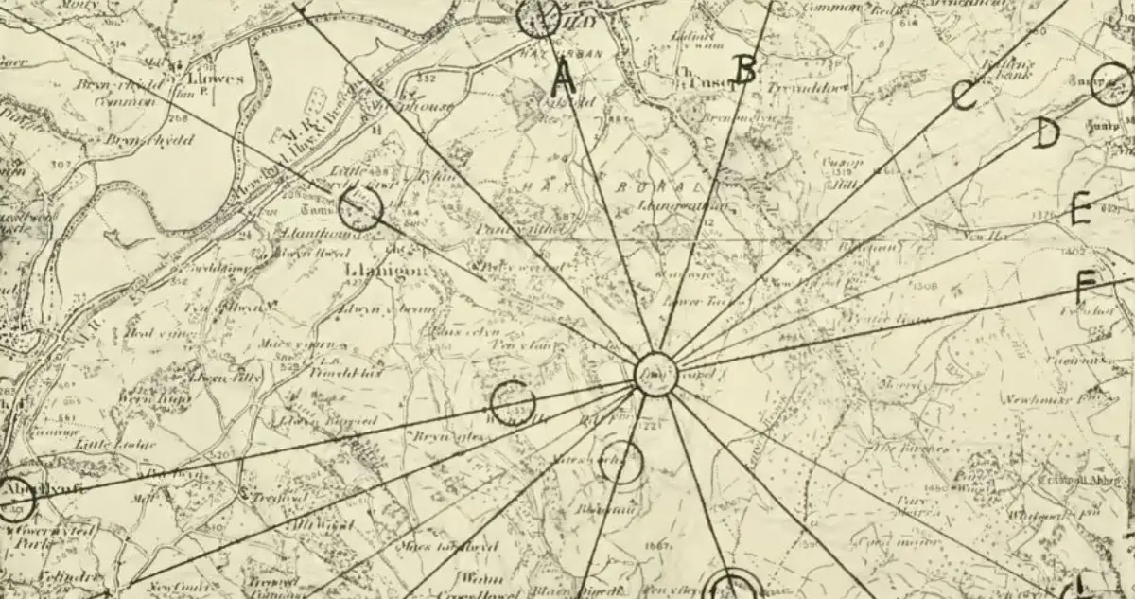

# Time Vortex: Definition and Concept

A **Time Vortex** in the context of *FusionGirl* is a high-energy, unstable phenomenon within the timestream that disrupts the natural flow of time and space. It manifests as a swirling distortion anchored to **Ley Lines** and **Ley Line Nodes**, which serve as the energetic highways and intersections of the multiverse. Time Vortices are both obstacles and opportunities, presenting unique challenges, rewards, and storylines.

## Relation to Ley Lines and Ley Line Nodes

1. **Ley Lines as Temporal Pathways**:
   * Ley Lines in *FusionGirl* are the conduits through which time and energy flow, connecting various realities and timelines.
   * A Time Vortex can form when a Ley Line becomes overloaded or disrupted, often due to interdimensional interference, massive energy spikes, or tampering by antagonists like the **Draken Seforthi** or The **Nefarium**.
2. **Ley Line Nodes as Stabilization Points**:
   * Ley Line Nodes are energetic hubs where multiple Ley Lines converge, acting as natural anchors for the timestream.
   * Time Vortices frequently appear at these nodes, threatening to destabilize the network and ripple chaos across connected realities.
3. **Dynamic Interaction**:
   * Players must navigate Ley Lines to reach these Nodes, using their **Magneto Speeder** or Universal Magic to stabilize or collapse the vortex, depending on the strategic goal.

## 

# Gameplay Integration

## Core Challenges:

* **Navigational Hazards**:
  + Time Vortices distort the surrounding area, creating gameplay challenges such as gravitational anomalies, shifting terrain, and time dilation (e.g., slowed movement or accelerated enemy attacks).
* **Unpredictable Threats**:
  + Vortex-affected zones are often populated by unstable entities like time-warped enemies, rogue robots, or fractured dimensional echoes of NPCs and factions.
* **Puzzle Mechanics**:
  + Closing a vortex involves solving complex **Universal Language puzzles** that mirror the harmonic frequencies of the affected Ley Line. These puzzles escalate in difficulty based on the size and energy of the vortex.

## Player Actions:

* **Stabilization**:
  + Players can choose to stabilize the vortex, reinforcing the Ley Line network and restoring balance. This action often unlocks new areas, strengthens alliances with factions like the **Earth Alliance Space Force**, and earns **Karma Points**.
* **Controlled Collapse**:
  + In some cases, collapsing a vortex is strategically advantageous, such as when it leads to new timelines or destroys enemy footholds in the multiverse. This may, however, have unintended consequences, introducing moral and narrative complexity.
* **Time Manipulation**:
  + Players can utilize **Psionic Abilities** to slow or accelerate time within the vortex, giving them tactical advantages in combat or puzzle-solving.

## Rewards:

* Successfully interacting with a Time Vortex can yield:
  + **Rare Resources**: Unique materials required for crafting advanced psionic devices or upgrading the Magneto Speeder.
  + **Timeline Keys**: Artifacts that unlock restricted realities or alternate futures.
  + **Faction Loyalty**: Enhanced standing with factions dependent on Ley Line stability.

# Narrative Impact

1. **Driving the Story**:
   * Time Vortices are central to the overarching narrative of repairing the timestream and preventing catastrophic futures.
   * Major story arcs often revolve around large-scale Time Vortex events, forcing players to make impactful decisions about which timelines to save or sacrifice.
2. **Ethical Dilemmas**:
   * Stabilizing or collapsing a vortex can have far-reaching consequences. For instance:
     + **Saving a Timeline**: Preserves a future at risk but may strengthen enemies elsewhere.
     + **Collapsing a Timeline**: Removes a significant threat but risks erasing entire realities and their inhabitants.
3. **Interaction with the Draken Seforthi**:
   * The **Draken Seforthi** use Time Vortices as tools to manipulate and consume planetary cores. Players must thwart their schemes by mastering vortex mechanics and leveraging alliances.

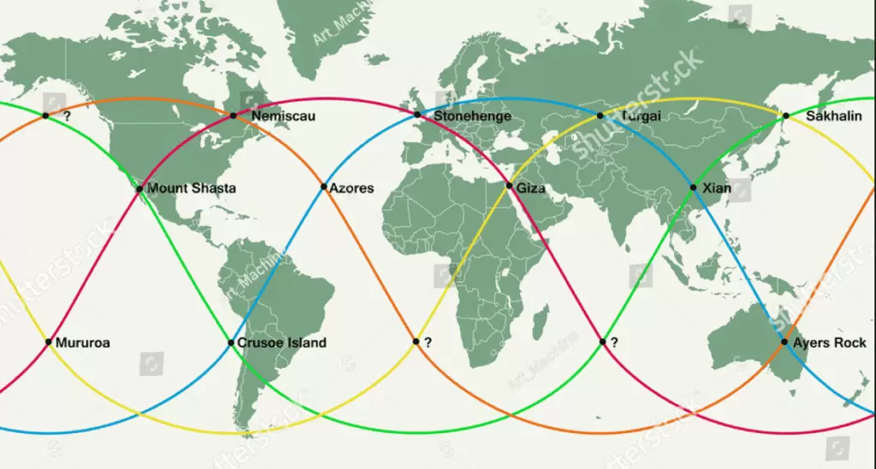

# Mechanics Overview

| **Feature** | **Gameplay Mechanic** | **Player Objective** |
| --- | --- | --- |
| **Time Vortex Formation** | Triggered by narrative events, enemy interference, or gameplay choices. | Reach the vortex and assess the situation. |
| **Ley Line Navigation** | Use the Magneto Speeder to traverse affected Ley Lines. | Arrive at the vortex while avoiding hazards. |
| **Stabilization or Collapse** | Solve Universal Language puzzles, combat threats, and manipulate time. | Restore or remove the vortex for strategic benefits. |
| **Rewards and Consequences** | Unlock new timelines, earn rare resources, or suffer ripple effects. | Shape the multiverse and influence faction dynamics. |

## Long-Term Integration

Time Vortices evolve as the player progresses:

* **Proto FusionGirl**: Introduces basic vortex mechanics, focusing on simple stabilization tasks and narrative exposure.
* **FusionGirl**: Expands mechanics with advanced puzzles, time manipulation abilities, and high-stakes vortex decisions.
* **Final FusionGirl**: Features massive, multiverse-spanning vortex events requiring multiplayer collaboration and deep narrative engagement.

###### Time Vortices in *FusionGirl* embody the interplay between exploration, mechanics, and narrative. They challenge players to master Universal Language, navigate dynamic environments, and make impactful choices, ensuring a deeply engaging and memorable gameplay experience.